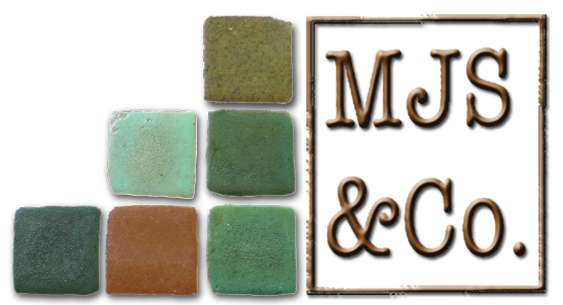
Obamacare Program Integrity Provisions:
Are They Vulnerable to Repeal?

Congressional Republican leaders plan to repeal the Affordable Care Act (Obamacare) using the budget reconciliation process in order to avoid a filibuster by Senate Democrats. Due to Senate rules, only provisions that either save or spend taxpayer dollars, such as enhanced provider screening (sec. 6401 in Subtitle E, see chart below) that was estimated to save $100 million dollars, may be repealed with a simple majority. Provisions that do not produce a change in outlays or revenues, such as the requirement for Medicaid RAC programs (sec. 6411 in Subtitle E), may not be repealed with a simple majority because that provision has no budgetary impact.

Congressional Republican leaders stated they would use a repeal bill passed earlier this year (H.R. 3762) as a model for a new repeal bill that Congress intends to take up in February 2017. H.R. 3762 was passed using budget reconciliation by the House and Senate but was vetoed by President Obama. The Congressional Budget Office (CBO) scored H.R. 3762 as saving around $500 billion over 10 years. Republicans may choose to repeal deficit-reducing program integrity provisions in the upcoming repeal bill in order to put these savings toward another priority later this year, such as business tax reform.

The chart below includes all program integrity provisions in Obamacare. As it illustrates, many of the provisions could have been repealed in H.R. 3762, but were not. In writing the new repeal bill, Congress may include the provisions below that either save or cost money. In particular, the reconciliation bill could repeal the additional funding for the Centers for Payment Integrity (Section 1303 in Subtitle D)

Description | Section | CBO Score 2010-2019  ($ in Billions) | Could be Repealed in 2017 Reconciliation Bill
Subtitle D—Reducing Fraud, Waste, and Abuse
Limits community mental health center that may provide Medicare partial hospitalization services | 1301 | -0.6 | Yes
Repeals Medicare prepayment medical review limitations to facilitate additional reviews designed to reduce fraud and abuse. | 1302 | -0.1 | Yes
Makes additional appropriations to the Health Care Fraud and Abuse Control (HCFAC) Account of the Federal Hospital Insurance Trust Fund for FY2011-FY2016 and makes additional appropriations to the Medicaid Integrity Program for FY2010 and each subsequent year, indexed for inflation. | 1303 | 0.3 | Yes
90-Day Period of Enhanced Oversight for Initial Claims of DME Suppliers | 1304 | -0.2 | Yes
Subtitle E—Medicare, Medicaid, and CHIP Program Integrity Provisions
Provider Screening and Other Enrollment Requirements Under Medicare, Medicaid, and CHIP | 6401 | -0.1 | Yes
Requires the Medicaid Integrity Program and Medicaid Integrity Program contractors to provide the HHS and OIG with performance statistics. Federal matching funds may be withheld from states that do no report enrollee encounter data to MMIS in a timely manner. Increases funding for the Medicare Integrity Program by the percentage increase in the consumer price index over the previous year. Other Medicare and Medicaid Program Integrity Provisions | 6402 | -2.9 | Yes
Elimination of Duplication Between the Healthcare Integrity and Protection Data Bank and the National Practitioner Data Bank | 6403 | 0 | No
Maximum Period for Submission of Medicare Claims | 6404 | 0 | No
Physicians Who Order Items or Services Required to Be Medicare-Enrolled Physicians or Eligible Professionals | 6405 | -0.4 | Yes
Requirement for Physicians to Provide Documentation on Referrals to Programs At High Risk of Waste and Abuse | 6406 | 0 | No
Face to Face Encounter With Patient Required Before Physicians May Certify Eligibility for Home Health Services or Durable Medical Equipment Under Medicare | 6407 | -1.0 | Yes
Revises civil monetary penalties for making false statements or delaying inspections | 6408 | 0 | No
Medicare Self-Referral Disclosure Protocol | 6409 | 0 | No
Adjustments to the Competitive Acquisition Program in Medicare for Durable Medical Equipment, Prosthetics, Orthotics, and Supplies. Requires the Secretary to: (1) expand the number of areas to be included in round two of the competitive bidding program from 79 to 100 of the largest metropolitan statistical areas; and (2) use competitively bid prices in all areas by 2016. | 6410 | -1.4 | Yes
Expands the Recovery Audit Contractor program to Medicaid, Medicare+Choice and Prescription Drug Program* | 6411 | 0 | No
Directs the U.S. Sentencing Commission to amend the Federal Sentencing Guidelines to provide two-level, three-level, and four-level increases in the offense level for any defendant convicted of a federal health care offense relating to a government health care program of a loss between $1 million and $7 million, between $7 million and $20 million, and at least $20 million, respectively. | 10606 | 0 | No
Subtitle F—Additional Medicaid Program Integrity Provisions
Termination of Provider Participation Under Medicaid If Terminated Under Medicare or Other State Plan | 6501 | 0 | No
Medicaid Exclusion From Participation Relating to Certain Ownership, Control, and Management Affiliations | 6502 | 0 | No
Billing Agents, Clearinghouses, or Other Alternate Payees Required to Register Under Medicaid | 6503 | 0 | No
Requirement to Report Expanded Set of Data Elements Under MMIS to Detect Fraud and Abuse | 6504 | 0 | No
Prohibition on Payments to Institutions or Entities Located Outside of the United States | 6505 | 0 | No
Overpayments | 6506 | 0.1 | Yes
Mandatory Medicaid Use of Medicare National Correct Coding Initiative | 6507 | -0.3 | Yes

Scorekeeping Guideline #14 (which was adopted by Congress in the conference report for the Balanced Budget Act of 1997) states that “No increase in receipts or decrease in direct spending will be scored as a result of provisions of a law that provides direct spending for administration or program management activities.”. This guideline applies to section 1303 (HCFAC) and section 6411 (RAC Program). If scoreable, the RAC Program and HCFAC spending would, over 10 years, save $200 million and $2.1 billion respectively.

