National Lifeline Verifier

One step closer to the National Lifeline Verifier working in all 50 states, DC and the territories.
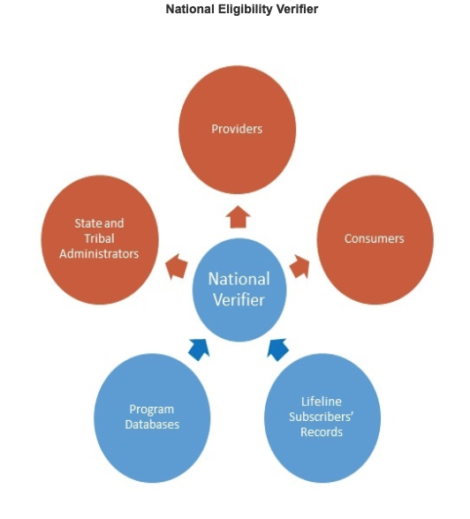
The FCC established a National Eligibility Verifier to make independent subscriber eligibility determinations, rather than relying solely on Lifeline service providers, which have a conflict of interest in the process. Consumers, providers, and state and Tribal administrators access components of the National Verifier to confirm eligibility, facilitate administration and reduce waste, fraud, and abuse. Accenture holds the contract as the National Eligibility Verifier.

In December 2019, the FCC launched an application programming interface (API) to connects carriers’ systems to the National Eligibility Verifier in order to send applicant information directly for an eligibility check, thereby reducing the paperwork required from potential subscribers. The National Eligibility Verifier has a nationwide automated connection between the Medicaid program and the Department of Housing and Urban Development.

56 States, DC and Territories and hard launch date:
- CO effective November 2, 2018
- MS effective November 2, 2018
- MT effective November 2, 2018
- NM effective November 2, 2018
- UT effective November 2, 2018
- WY effective November 2, 2018
- MO as of December 4, 2018
- NC as of December 4, 2018
- PA as of December 4, 2018
- TN as of December 4, 2018
- HI effective January 15, 2019
- ID effective January 15, 2019
- NH effective January 15, 2019
- ND effective January 15, 2019
- SD effective January 15, 2019
- Guam effective January 15, 2019
- AK effective May 7, 2019
- American Samoa effective May 7, 2019
- DE effective May 7, 2019
- DC effective May 7, 2019
- ME effective May 7, 2019
- Northern Mariana Islands effective May 7, 2019
- RI effective May 7, 2019
- USVI effective May 7, 2019
- IN effective June 11, 2019
- KY effective June 11, 2019
- MI effective June 11, 2019
- AZ effective October 23, 2019
- CT effective October 23, 2019
- GA effective October 23, 2019
- IA effective October 23, 2019
- KS effective October 23, 2019
- NE effective October 23, 2019
- NV effective October 23, 2019
- NY effective October 23, 2019
- VT effective October 23, 2019
- VA effective October 23, 2019
- WV effective October 23, 2019
- AL January 22, 2020.
- AR January 22, 2020.
- LA January 22, 2020.
- MD January 22, 2020.
- MA January 22, 2020.
- NJ January 22, 2020.
- OK January 22, 2020.
- PR January 22, 2020.
- SC January 22, 2020.
- WA January 22, 2020.
- FL March 24. 2020
- IL March 24. 2020
- MN March 24. 2020
- OH March 24. 2020
- WI March 24. 2020
These states operate their own comprehensive systems in place of the National Lifeline Accountability Database to prevent duplicative federal Lifeline support and Lifeline will rely on those systems to prevent duplications. The verifier will use the states’ data to validate Lifeline claims and will review the eligibility information and documentation.
- CA (modified soft) effective on December 20, 2019.
- TX (modified soft) effective on December 20, 2019.
- OR (modified soft) effective on December 20, 2019.

